**Bangladesh University of Business and Technology**



**Department of Computer Science & Engineering Course Title: Operating System Lab**

**Course No: CSE 316**

**Intake: 44 (Day)**

**Section: 8**

Lab Report

**Submitted to**

Ali Azgor

Lecturer

Department of Computer Science & Engineering

**Submitted by**

Name: Md. Zobayer Hasan Nayem

ID: 19202103274

Intake: 44

Section: 08

**Experiment No: 07**

**Experiment Title:** Shell script commands, File Creating, File Read & Write, File Handling Using Bash File.

**Theory: -** Bash is a shell program written by Brian Fox as an upgraded version of Bourne Shell program 'sh'. It is an open-source GNU project. It provides functional improvements over Bourne Shell for both programming and interactive uses. It includes command line editing, key bindings, command history with unlimited size, etc. In basic terms, Bash is a command line interpreter that typically runs in a text window where user can interpret commands to carry out various actions. The combination of these commands as a series within a file is known as a Shell Script. Bash can read and execute the commands from a Shell Script.

**Question-01:** Write a bash program to create a given file System.

newStudent.txt

OS

Sec7

Sec8

44

Oslab.txt

alstudent.txt

Day

Eve

Circuit.txt

EEE

CSE

CE

BUBT

**Command:**

#!/bin/bash

cd ~/Zobayer

mkdir BUBT

cd BUBT

mkdir EEE CSE CE

cd EEE

touch circuit.txt

cd ..

cd CE

touch new_student.txt

cd ..

cd CSE

mkdir Day Eve

cd Eve

touch os_lab.txt

cd ..

cd Day

mkdir 44

touch al_student.txt

cd 44

mkdir sec7 sec8

cd sec8

mkdir os

**Queestion-02:** Write a bash program to create any file in OS Directory?

**Command:**

cd ~/Zobayer/BUBT/CSE/Day/44/sec8/os

touch bash_file.sh

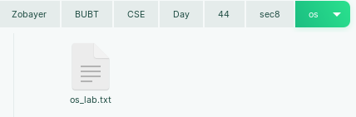

**Question-03:** Write a bash program to rename to rename newStudent.txt to civil_student.txt?

**Command:**

#!/bin/bash

cd ~/Zobayer/BUBT/CE

mv new_student.txt civil_student.txt

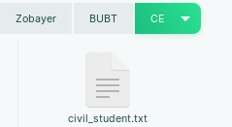

**Question-04:** Write a program to copy the file circuit.txt in the 44 Directory?

**Command:**

#!/bin/bash

cd ~/Zobayer/BUBT/EEE

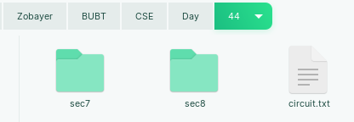cp circuit.txt ~/Zobayer/BUBT/CSE/Day/44

**Question-05:** Write a bash program to move the oslab.txt into section8 OS directory?

**Command:**

#!/bin/bash

cd ~/Zobayer/BUBT/CSE/Eve

mv os_lab.txt ~/Zobayer/BUBT/CSE/Day/44/sec8/os

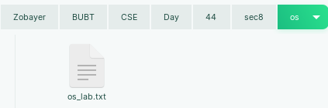

**Programming on Bash File**

**Question: Addition two number?**

**Command:**

#!/bin/bash

echo "Enter Two Number"

read a

read b

sum=$(( $a + $b ))

sub=$(( $a - $b ))

mul=$(( $a * $b ))

echo "Sum: $sum"

echo "Sub: $sub"

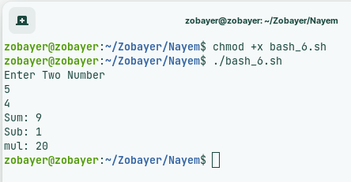echo "mul: $mul"

**Question_02:** Analyze Grater and Smallest Number between two numbers?

**Command:**

#!/bin/bash

echo "Enter value of: "

read a

read b

if [ $a -gt $b ]

then

echo "$a is biggest"

else

echo "$b is biggest"

fi

